SOCIAL MEDIA ANALYTICS

OLYMPICS WINTER GAMES MILANO – CORTINA 2026
Analisi del Sentiment e della Rete Social su Reddit

- OBJECTIVE
This project is part of the Social Media Analytics framework and focuses on the online perception of the Milan-Cortina 2026 Winter Olympic Games, an internationally significant event to be held in Italy. The primary objective is to analyze the debate that developed on the Reddit platform in the months leading up to and during the event, examining three key dimensions:
- Sentiment Analysis: measuring the emotional tone of comments posted in the main thematic subreddits (Olympics, Figure Skating, hockey, biathlon, curling, skiing, snowboarding), distinguishing between positive, negative, and neutral comments and tracking their evolution over time.
- Named Entity Recognition (NER): identifying the most frequently mentioned entities (athletes, nations, organizations, places, events) to understand which subjects and topics dominate the conversation.
- Social Network Analysis (SNA): reconstructing the network of interactions between users (who responds to whom) and identifying the most influential figures, discussion communities, and the network's topological structure.
The joint analysis of these three dimensions allows us to answer research questions such as: how is sentiment distributed across different sports communities? Who are the most influential users? Are there distinct thematic communities? Which nations and athletes dominate the discourse?
2. DATA
2.2 Collection Strategy
The data was collected using Arctic Shift, a public API that allows querying Reddit's historical archive without rate restrictions. The collection occurred in two phases:
- Phase 1 - Posts: collection of posts published in the target subreddits containing keywords related to the Winter Olympics ("Milano-Cortina", "2026 Olympics", "Winter Olympics", etc.). 908 posts were retrieved.
- Phase 2 - Comments: for each post, paginated download of all comments via the /api/comments/search endpoint with the link_id parameter. Measures were adopted to manage pagination (after field), with 0.8-second pauses between requests to comply with API usage policies.
Deleted comments ([deleted], [removed]) or comments with empty bodies were excluded from the collection. For each comment, the following information was saved: unique identifier, author, body, upvote, creation timestamp, subreddit, discussion depth, and parent-child relationship (parent_id).

2.3 Dataset Description
Parameter | value
Processed Posts | 908
Total comments collected | 24.745
Unique authors | 9.355
Network arches (user-to-user interactions) | 20.691
Subreddits analyzed | 7 (olympics, FigureSkating, hockey, biathlon, Curling, skiing, snowboarding)
Period covered | End of December 2024 - end of March 2025
NER Champion | 8,000 comments (stratified random sample)

The distribution by subreddit shows a clear prevalence of olympics (8,615 comments, 35%) and FigureSkating (7,254 comments, 29%), followed by hockey (3,256), biathlon (2,704) and Curling (2,307). The subreddits skiing (345) and snowboarding (264) show much lower volumes, indicating a lower participation of their respective communities in the Olympic discussion.
2.4 Preprocessing
Before analysis, the comment text was lightly preprocessed: URLs and Reddit markup were removed, and whitespace was normalized. No aggressive lemmatization was applied to preserve the semantic context necessary for transformer-based sentiment models (RoBERTa). The final dataset was saved to Google Drive in the file reddit_comments_sentiment.csv, containing the original columns enriched with labels and the sentiment scores produced by the models.
3. ANALYSIS MODELS
3.1 Sentiment Analysis – VADER
VADER (Valence Aware Dictionary and sEntiment Reasoner) is a rule-based lexical model designed specifically for social media text. It returns a compound score in the range [-1, +1], where values ​​above 0.05 indicate positive sentiment, below -0.05 negative sentiment, and between the two extremes neutral. It was chosen for its computational efficiency (applicable to the entire corpus of 24,745 comments) and its robustness with informal text, abbreviations, and expressive punctuation typical of Reddit.
3.2 Sentiment Analysis – RoBERTa
As a second model, cardiffnlp/twitter-roberta-base-sentiment was used, a fine-tuned transformer model on Twitter data for sentiment classification into three classes (positive, neutral, negative). RoBERTa captures long-distance contextual dependencies that VADER cannot capture. The comparison between the two models (agreement matrix) provides information on the robustness of the results.
3.3 Named Entity Recognition (NER)
To extract named entities, spaCy's en_core_web_sm model was used, applied to a random sample of 8,000 comments (limited by computational complexity). The model identifies the following categories relevant to the Olympic context: PERSON (athletes and people), GPE (countries and cities), ORG (organizations and TV broadcasters), EVENT (sporting events), LOC (geographical locations). Text was limited to 1,000 characters per comment to ensure processing speed. The extracted entities were aggregated by frequency and cross-referenced with the sentiment of the comment they originated from.
3.4 Social Network Analysis
The interaction network was constructed from parent-child relationships between comments: a directed arc runs from the author of a comment to the author of the comment (or post) to which they are replying. The following were calculated:
- In-degree centrality: number of replies received by each user (popularity measure).
- PageRank: influence measure that takes into account the quality (not just the quantity) of incoming connections.
- Community detection: Greedy Modularity Optimization algorithm on an undirected version of the network, which maximizes the graph's modularity to find dense partitions of nodes.
The analysis was conducted on the filtered subgraph of nodes with at least 5 interactions, resulting in 690 users and 2,571 edges, to eliminate isolated nodes and make the visualization interpretable.
4. RESULTS
4.1 Global Sentiment
The overall sentiment of the corpus is predominantly positive: 55% of comments are positive according to VADER, 21% negative, and the remaining 24% neutral. This reflects the enthusiastic and celebratory nature typical of sports communities on Reddit, where discussion revolves around cheering, shared expectations, and passion for the Olympic sports. The global average compound score stands at +0.24, significantly above the neutral threshold (0.05), confirming an overall favorable sentiment toward the Games.
4.2 Sentiment by Subreddit
The disaggregated analysis by subreddit reveals significant differences between the different communities. Biathlon presents the most positive sentiment of the entire corpus, with 62% of comments classified as positive and an average VADER of 0.31: the biathlon community appears very cohesive and supportive towards athletes. FigureSkating follows with 58% positive and an average VADER of 0.26, confirming a particularly enthusiastic fan base. In contrast, skiing shows the highest percentage of negative comments (34%) and the lowest average VADER (0.09), suggesting a more critical debate, likely linked to technical controversies, disappointing results, or discussions on competition formats. Curling, hockey, olympics, and snowboarding are intermediate, with positive percentages between 52% and 53%.

Tabella 1- VADER Sentiment distribution by subreddit
Subreddit | Neg. | Pos. | Neu. | VADER medium | No. of comments | % global
olympics | 21% | 52% | 27% | 0.21 | 8.615 | 34.8%
FigureSkating | 20% | 58% | 21% | 0.26 | 7.254 | 29.3%
hockey | 22% | 52% | 26% | 0.19 | 3.256 | 13.2%
biathlon | 20% | 62% | 18% | 0.31 | 2.704 | 10.9%
Curling | 25% | 52% | 23% | 0.18 | 2.307 | 9.3%
skiing | 34% | 49% | 17% | 0.09 | 345 | 1.4%
snowboarding | 22% | 53% | 25% | 0.19 | 264 | 1.1%
Total | 21% | 55% | 24% | 0.24 | 24.745 | 100%

4.3 VADER vs. RoBERTa Comparison
The comparison between the two sentiment models shows an overall agreement of 57.6%, a moderate value that reflects the architectural differences between a rule-based lexical approach (VADER) and a contextual transformer (RoBERTa). The agreement is particularly high for the positive class: 88% of comments classified as positive by VADER are assigned the same label by RoBERTa. The most marked discrepancy concerns neutral comments according to RoBERTa: 47% of them are classified as positive by VADER, indicating that the latter tends to overestimate the positivity of comments that are ambiguous, ironic, or contain words with generally positive connotations but used in a neutral context. For negative comments, the agreement stands at 54%, with 32% of them reclassified as positive by VADER, likely due to the presence of negations or sarcasm that the lexical model does not effectively handle.
4.4 Temporal Evolution of Sentiment
Sentiment remained consistently positive throughout the entire time period analyzed (late December 2024 - late March 2025), with an average weekly compound fluctuating between 0.16 and 0.44. A few particularly noteworthy moments stand out: an initial peak around January 13, 2025 (VADER ~ 0.32), likely coinciding with positive news about preparations or official announcements from the Organizing Committee; a moderate decline around March 3 (VADER ~ 0.20), with a concomitant increase in the negative component, attributable to organizational controversies or sporting disappointments; and finally, a very sharp peak in the last week of March (VADER ~ 0.44), with almost zero negative comments, signaling a moment of strong collective enthusiasm as the final phase of preparations approaches. The analysis by subreddit over time highlights heterogeneous behavior: FigureSkating maintains a consistently positive level with a further acceleration at the end of March (VADER ~ 0.45); Curling shows the most abrupt variation, with a marked negative decline at the beginning of March (VADER ~ -0.14), the only case of a negative compound in the entire dataset; biathlon records the highest average values ​​and an increasing trend.
4.5 Positive and Negative Comment Vocabulary
An analysis of the vocabulary of comments classified as positive reveals a predominance of terms related to the event in a broad sense ("Olympic," "game," "team") and to the emotional-celebratory aspect ("great," "love," "gold," "medal," "best," "hope"). The word "thank" appears significantly frequently in positive comments, indicating interactions of gratitude and mutual support typical of passionate communities. In negative comments, alongside generic terms relating to the event ("Olympic," "game," "team"), negatively connoted words such as "bad," "wrong," "never," "rule," and "skating" emerge, suggesting that criticism focuses primarily on regulatory and refereeing issues and unmet expectations. The presence of "Russia" in negative comments is consistent with the debate over the exclusion of Russian athletes from the Games.
4.6 Named Entity Recognition
The NER analysis of the sample of 8,000 comments extracted several thousand entities divided into five categories. Among people, "Alysa" (Alysa Liu, American figure skater) is the most cited with almost 100 mentions, followed by "Kaori" (Kaori Sakamoto, Japanese figure skater) and "Ami" (Ami Sato). The fact that the three most mentioned people are all figure skaters reflects the weight of FigureSkating in the corpus. Among countries and cities, Canada leads with approximately 270 mentions, followed by Italy (~175) and the USA (~150): Canada's strong presence is consistent with that country's tradition in winter sports and its strong Reddit fan community. Italy and Milan occupy prominent positions as host country and host city. Among organizations, NBC and the NHL lead the ranking, reflecting the importance of American television coverage and ties to professional hockey. The most frequently mentioned event entity is "Olympics" with over 550 occurrences, followed by "Olympic" and "the Winter Olympics." Among locations, Europe and the Alps emerge as the most frequent, consistent with the event's geographic location.
The distribution of the most frequently mentioned athletes by subreddit highlights a clear thematic specialization: in FigureSkating, Alysa, Kaori, and Ami dominate; in hockey, Celebrini, Makar, and Crosby (prominent NHL hockey players) emerge; in biathlon, Sturla (Holm Laegreid), btn, and lou are among the most mentioned; in Curling, GB, Homan, and Kennedy are among the most mentioned. This segmentation confirms that each community maintains a strong disciplinary focus even within the broader Olympic discourse. Regarding sentiment associated with nations, Beijing records the highest value (VADER ~ 0.58), likely a positive reference to the previous Winter Olympics in 2022; Russia and Germany follow with positive values ​​(~0.31 and ~0.25); Sweden and Paris show the lowest values, although they remain in positive territory.
4.7 Social Network Analysis
Network Structure
The interaction network, built on the subgraph of users with at least five interactions, is composed of 690 nodes and 2,571 directed edges. The Greedy Modularity algorithm identified 74 distinct communities, with high modularity indicating a strong community structure. The network exhibits characteristics typical of social media interaction networks: a highly skewed degree distribution (few hubs with many connections, many peripheral nodes with few), a high diameter, and low density. This suggests that conversation is not uniformly distributed but is concentrated around a few highly active users.

Parameter | Value
Nodes (users) | 690
Edges (interactions) | 2.571
Selected communities | 74 (Greedy Modularity)
User with highest in-degree | Fun_With_Forks (over 1,200 responses received)
User with the highest PageRank | Fun_With_Forks (PR ~ 0.028)
Second in in-degree and PageRank | FliryVorru
High PageRank, low in-degree | SpiritualWatermelon (high-quality connections)

Centrality Measures
Fun_With_Forks dominates both the in-degree rankings (over 1,200 replies received) and the PageRank rankings (PR ~0.028), clearly ahead of the second-place profile. This profile suggests a central hub role in the network: not only does it receive many replies, but these in turn come from well-connected users, amplifying its indirect influence. FliryVorru ranks second in both metrics. An interesting case is SpiritualWatermelon, which ranks third in PageRank despite not being among the top in-degree: this indicates that its replies come from particularly influential users, giving its profile a qualitative rather than quantitative influence.
Communities and Subreddits
The distribution of communities by subreddit reveals a strong correspondence between the algorithmically detected communities and the subreddits to which users belong. Community 0, the largest, is almost exclusively composed of users of FigureSkating (1,878 nodes); Community 1 from hockey (1,044); Community 4 from Curling (527); Community 6 from biathlon (398). Olympics, on the other hand, does not correspond to a single community but is distributed across several sub-communities (2, 3, 5, 7), reflecting the greater thematic heterogeneity of that generalist subreddit. This pattern is consistent with the echo chamber hypothesis: users of each discipline interact mainly among themselves, with little cross-pollination towards other sports communities.
5. VISUALIZATIONS
All visualizations were produced with matplotlib and seaborn in Python, with consistent color palettes (green/red/yellow for positive/negative/neutral; blue for NER entities; orange and blue for network metrics). The graphs were saved in PNG format at 150 DPI. The individual visualizations produced are described and illustrated below, divided by thematic area.

5.1 Global Sentiment Distribution
The waffle chart was chosen to represent the global distribution of sentiment because it allows for an immediate proportional reading: each square corresponds to 1% of the total comments, making the bias toward the positive class visually evident (55 green squares versus 21 red and 24 yellow). It is a more intuitive form than the classic pie chart for three-category comparisons.
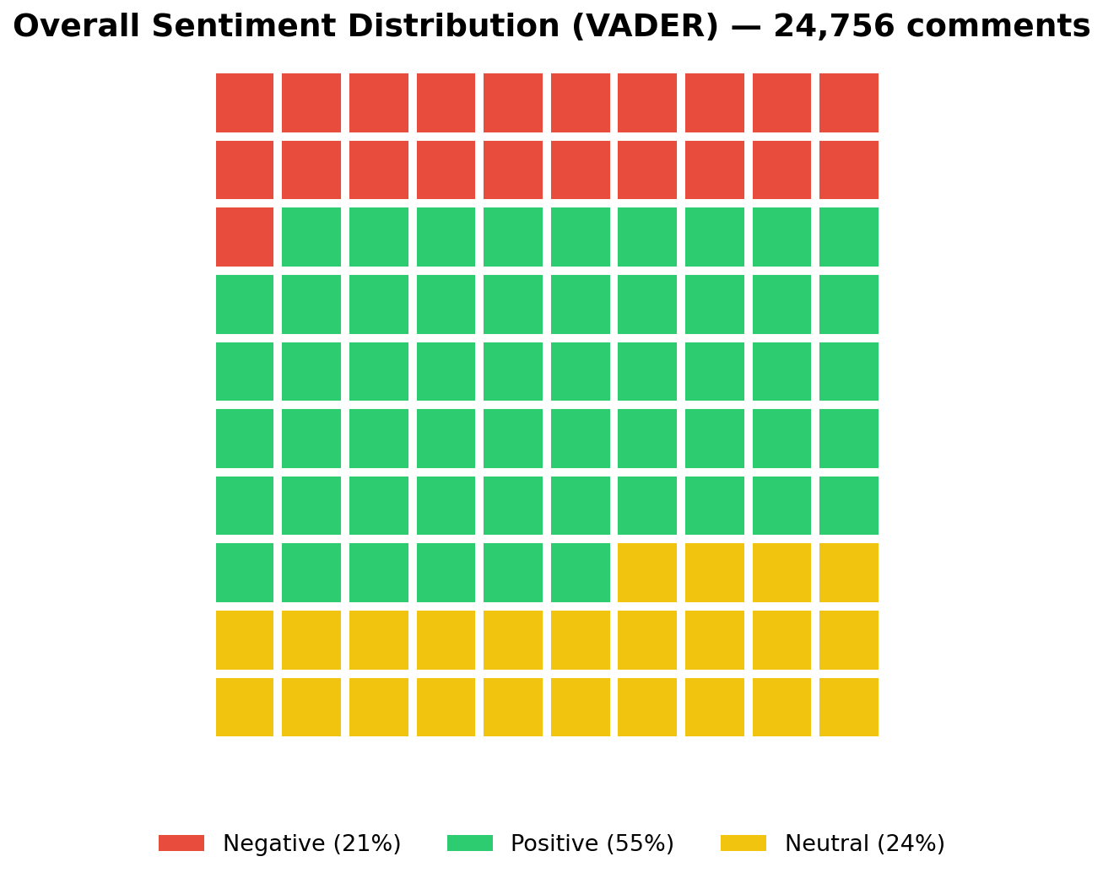
Figure 1- Global VADER sentiment distribution - 24,745 comments (waffle chart).

5.2 Sentiment Distribution by Subreddit
The replicated waffle chart for each subreddit (Figure 2) allows for a visual comparison of sentiment proportions across the seven communities. The 10x10 grid maintains the same relative scale, making the comparison immediate: it's clear that r/biathlon has the highest percentage of green and r/skiing the highest percentage of red. The horizontal bar panel (Figure 3) completes the picture by juxtaposing the mean VADER compound with standard error (green bars) with the RoBERTa distribution (stacked bars), revealing both the magnitude of sentiment and the consistency between the two models.
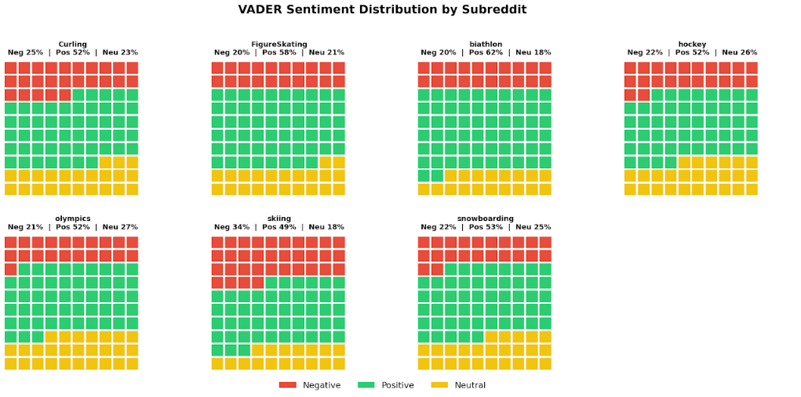
Figura 2-VADER sentiment distribution by subreddit (waffle chart, 10x10 scale).
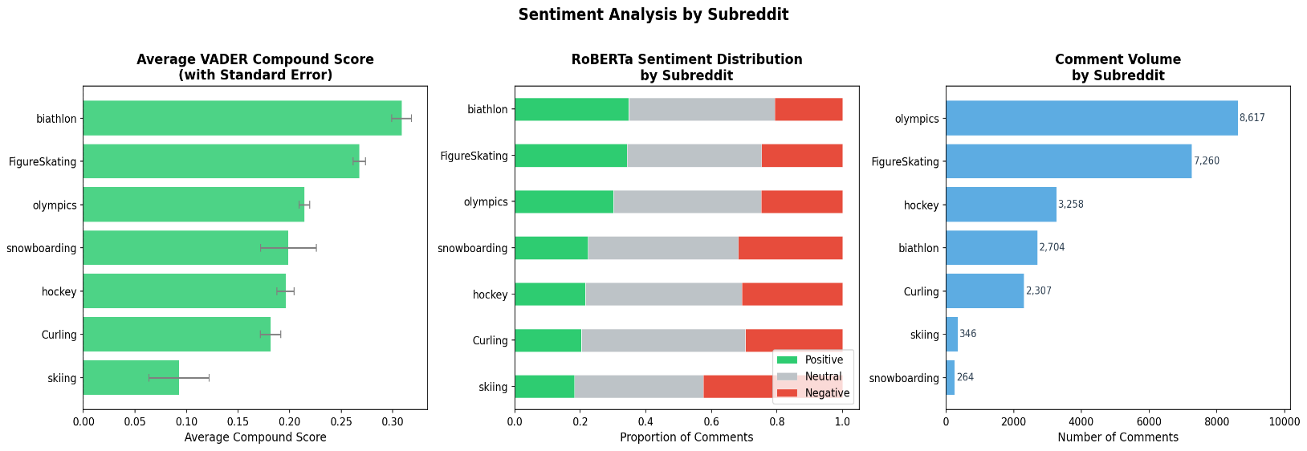
Figure 3 - Compound mean VADER with standard error (left) and RoBERTa distribution (center) by subreddit, with comment volume (right).
5.3 VADER vs. RoBERTa Comparison
The confusion matrix (heatmap) is the most effective choice for representing the degree of agreement between two three-class classifiers. The color coding (blue intensity proportional to frequency) allows for immediate identification of diagonal cells (agreement) versus off-diagonal cells (disagreement). The right panel shows the normalized percentages per row, eliminating the effect of different class sizes and making the agreement rates between positive, neutral, and negative classifiers comparable.
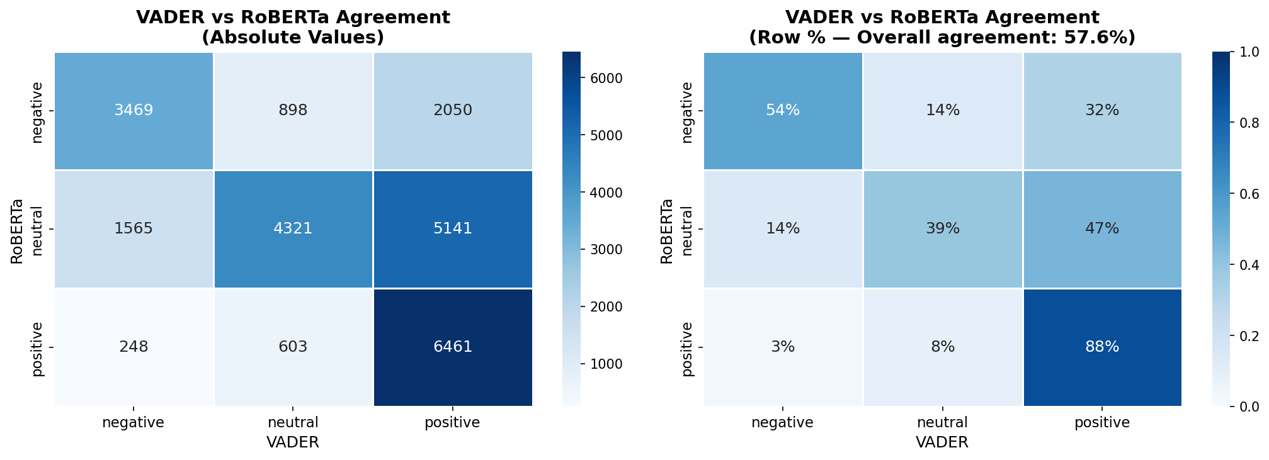
Figure 4 - VADER vs RoBERTa agreement matrix: absolute values (left) and percentages per row with overall agreement 57.6% (right).

5.4 Temporal Evolution of Sentiment
The two-panel chart (Figure 5) combines two complementary perspectives on the time axis: at the top, the weekly compound mean line with standard error band (shaded area) shows the sentiment trajectory and its uncertainty; at the bottom, the stacked area chart breaks down each week into proportions of positive, neutral, and negative sentiment, making visible not only the level but also the composition of sentiment. The use of two overlapping panels with a shared x-axis facilitates joint reading.
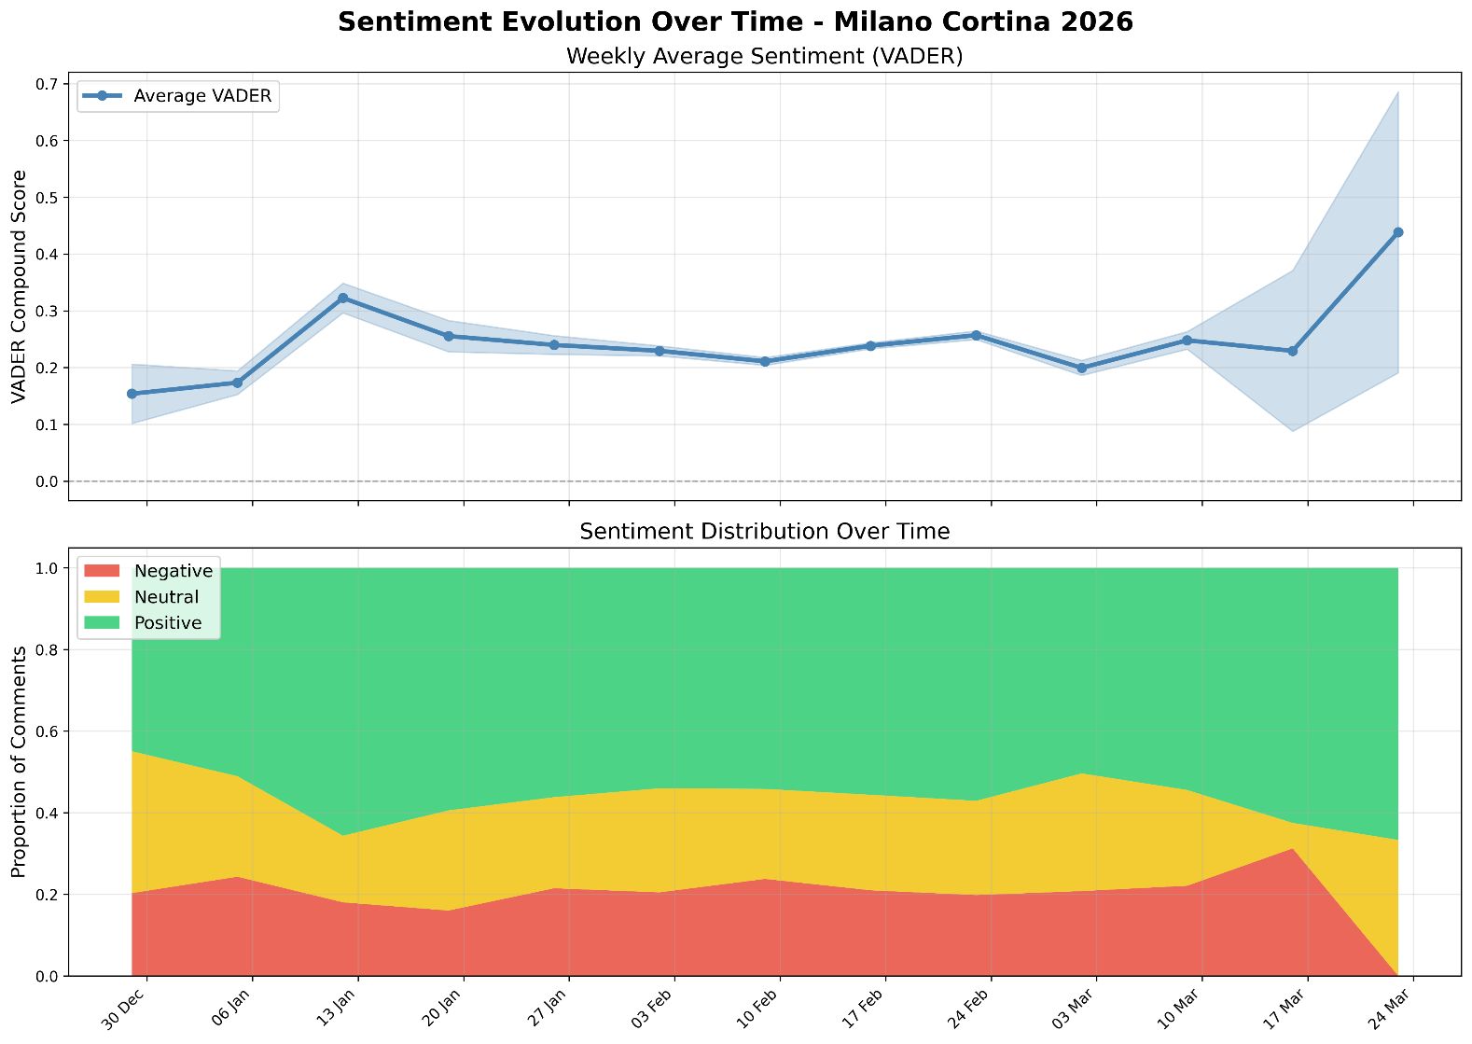
Figure 5 - Weekly evolution of VADER sentiment: compound average with error band (high) and proportional distribution by week (low).
Figure 6 replicates the temporal analysis separately for each subreddit, using a community panel with a shared x-axis. This layout allows us to compare sentiment trajectories across different communities while maintaining individual readability. The number of comments (n) is reported in each panel as a reference to the sample size.
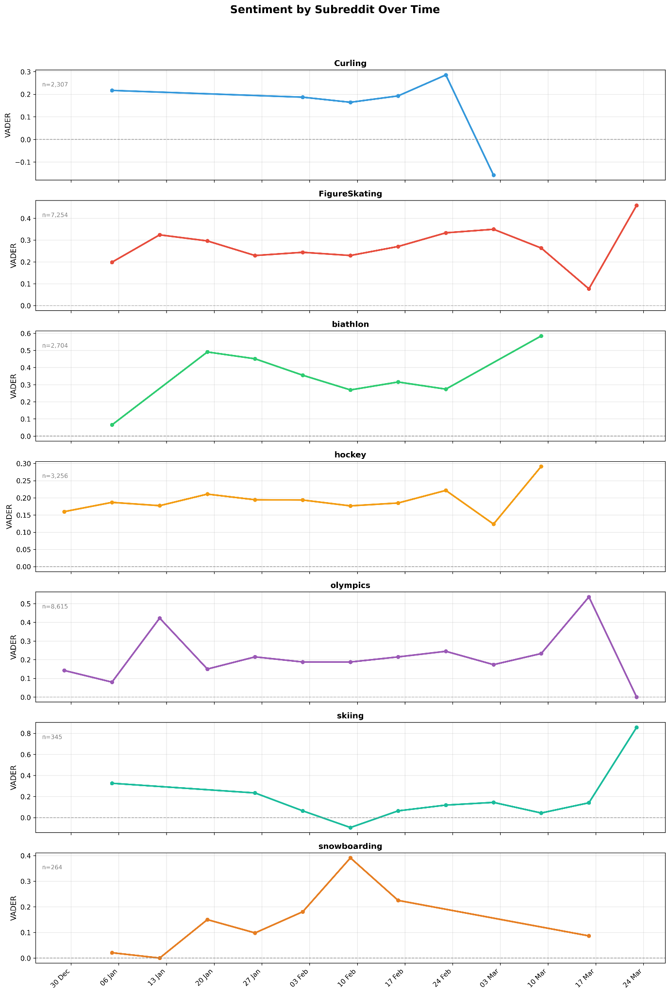
Figure 6 - Weekly evolution of VADER sentiment for each subreddit (overlapping panels, shared x-axis).

5.5 Sentiment Word Cloud
Word clouds (Figure 7) were generated separately for positive and negative comments, using frequency weighting based on font size. The color scale within the two clouds (shades of green for positive comments, shades of red for negative comments) adds a layer of visual coding that reinforces the color association established in the other graphs. Stop words and overly generic words were filtered out to highlight the semantically distinctive vocabulary of each class.
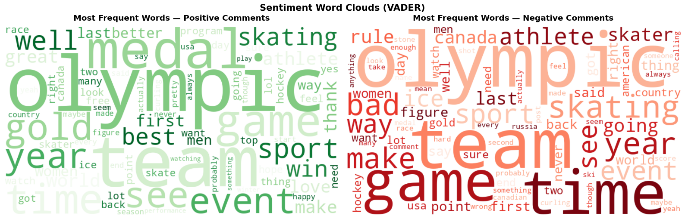
Figure 7 - Word cloud sentiment VADER: most frequent words in positive (left, green scale) and negative (right, red scale) comments.
5.6 Named Entity Recognition
Figure 8 presents the top 15 entities for each of the five relevant NER categories (People, Countries/Cities, Organizations, Events, Places) through side-by-side horizontal bar charts. Each category has a dedicated color (blue, green, red, orange, purple), and the bars are sorted by decreasing frequency. The multi-panel layout allows for cross-category comparisons while maintaining individual readability.
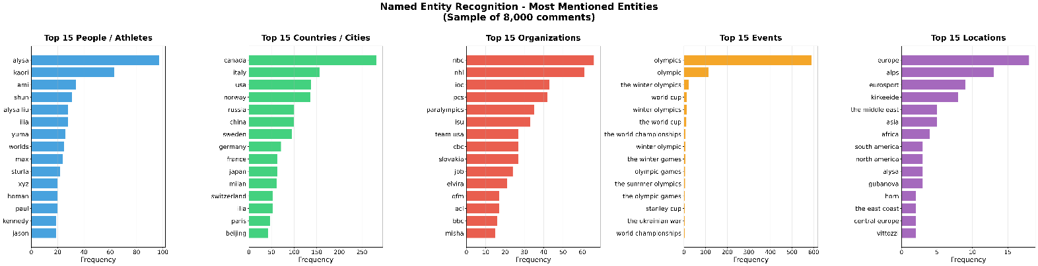
Figure 8 - Top 15 NER entities by category (sample 8,000 comments): People, GPE, Organizations, Events, Places.
Figure 9 breaks down the most cited people/athletes by subreddit, with a community panel. This allows us to identify the figures who dominate the conversation in each discipline and test the hypothesis of thematic specialization by community.
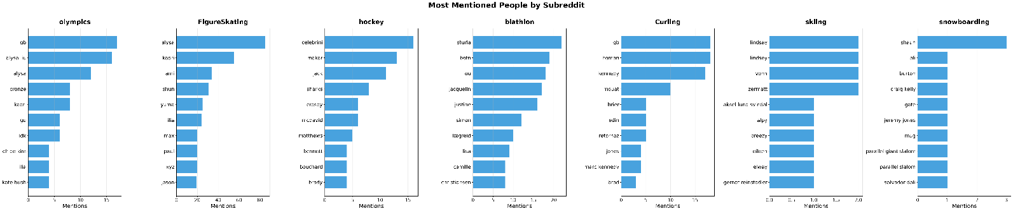
Figure 9 - Top 10 most mentioned athletes/people per subreddit (horizontal bar charts per panel).
Figure 10 shows the average VADER sentiment in comments mentioning each of the 15 most frequent countries/cities. The bars are sorted from highest to lowest sentiment, with green (positive) or red (negative) color determined by the sign of the value. The vertical dashed line at zero serves as a visual cue to identify entities with negative sentiment.
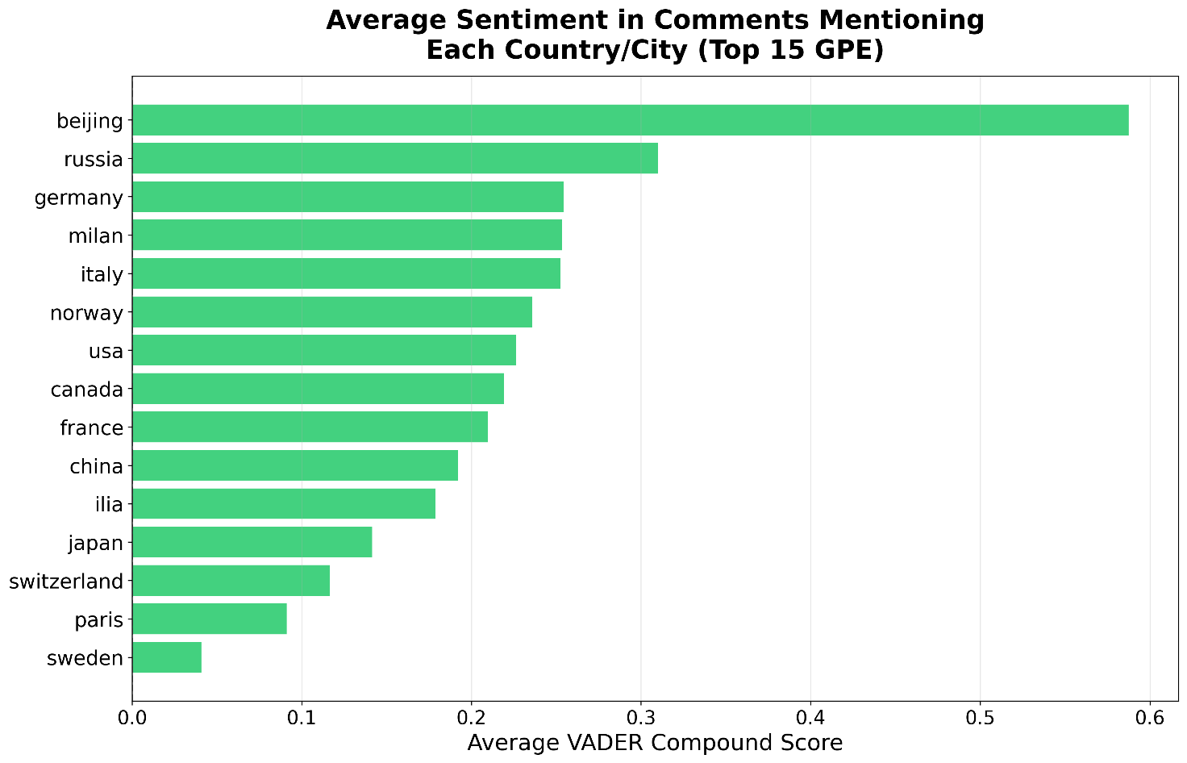
Figure 10 - Average VADER sentiment in comments mentioning major countries/cities (Top 15 GPE).

5.7 Social Network Analysis
Figure 11 shows the user interaction network using a force-directed layout (Fruchterman-Reingold): nodes are positioned in space so that frequently interacting users are closer together, making the clusters visible. The colors represent the 74 detected communities, the size of the nodes is proportional to the in-degree, and labels are displayed only for users with the highest centrality. The black background increases contrast and improves the readability of the clusters.
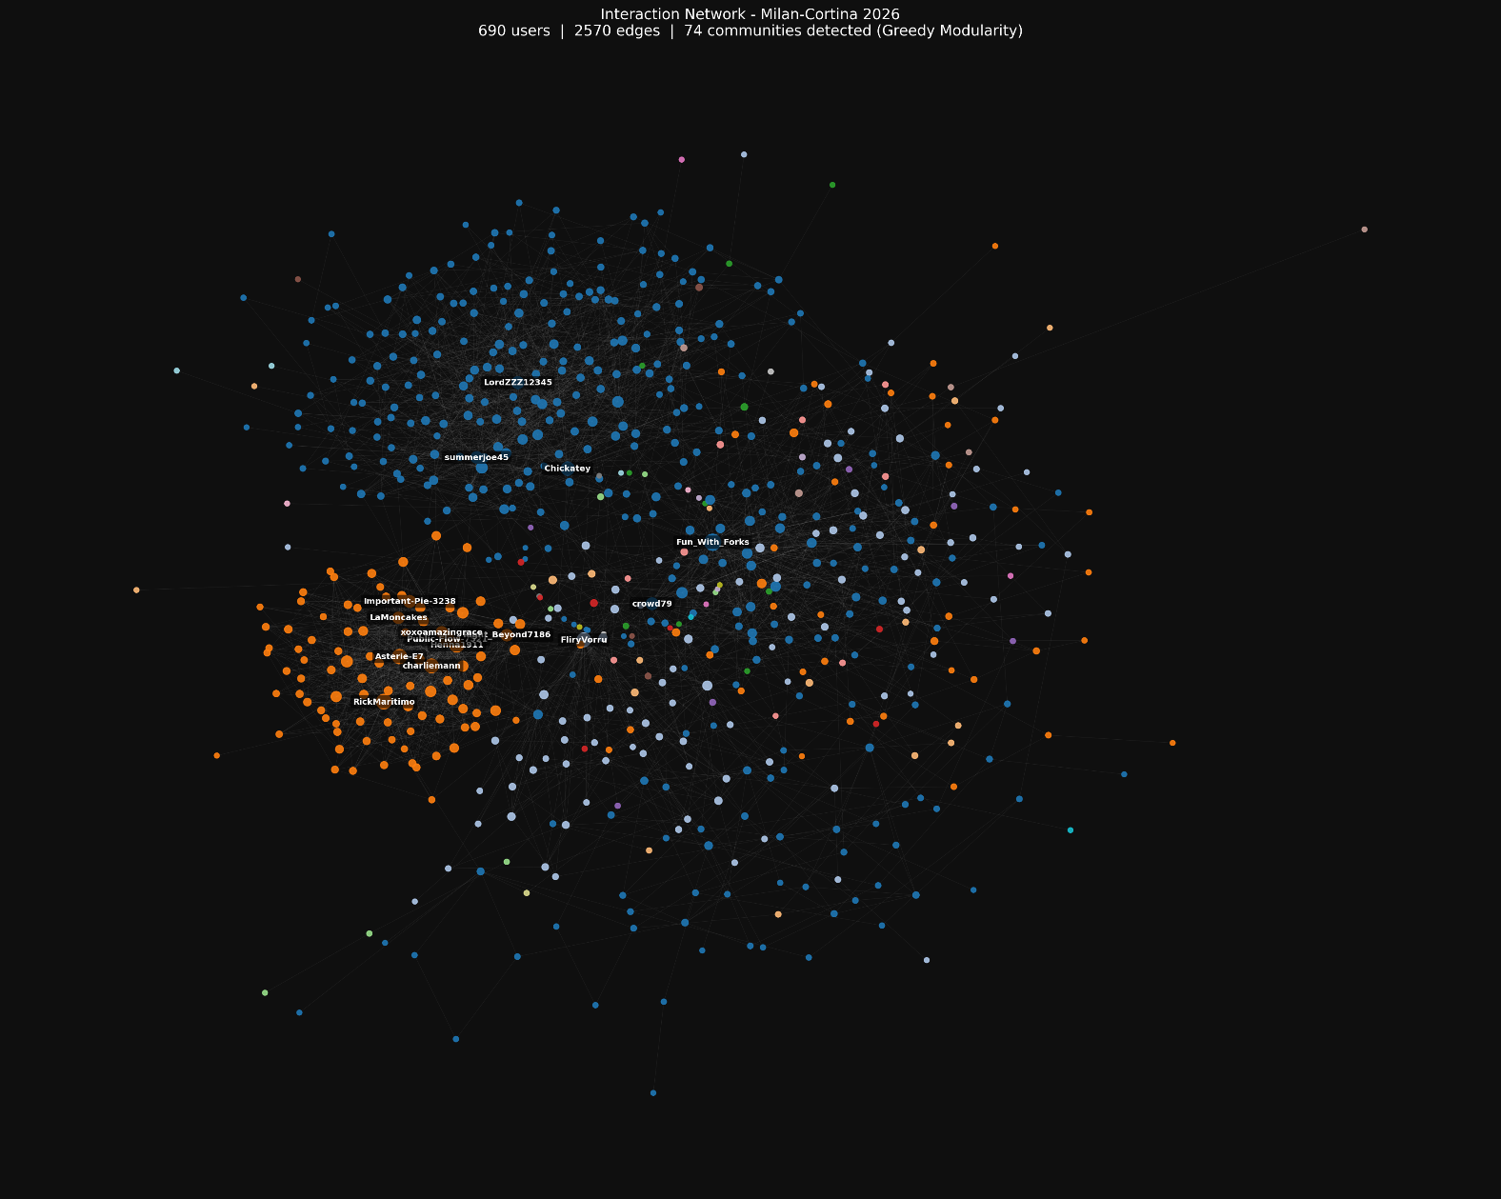
Figure 11 - User-to-user interaction network: 690 nodes, 2,571 edges, 74 detected communities (Greedy Modularity). Force-directed layout, color-coded communities.
Figure 12 displays two horizontal bar charts comparing in-degree (blue bars) and PageRank (orange bars) for the top 15 users for each metric. The dual panel allows you to quickly identify users who dominate in both metrics (absolute hubs) and those who excel in only one (quantitative vs. qualitative influence).
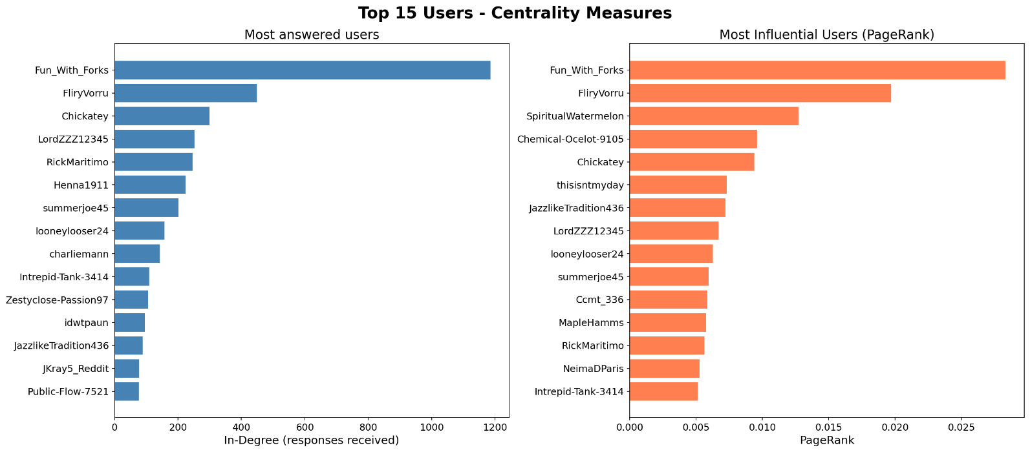
Figure 12 - Top 15 users by in-degree (left, responses received) and PageRank (right, influence on the network).
The community-subreddit heatmap (Figure 13) color-codes the number of users from each subreddit in each of the top 8 communities. The darker cells identify the dominant combinations, making the nearly one-to-one correspondence between detected communities and their respective subreddits immediately visible.
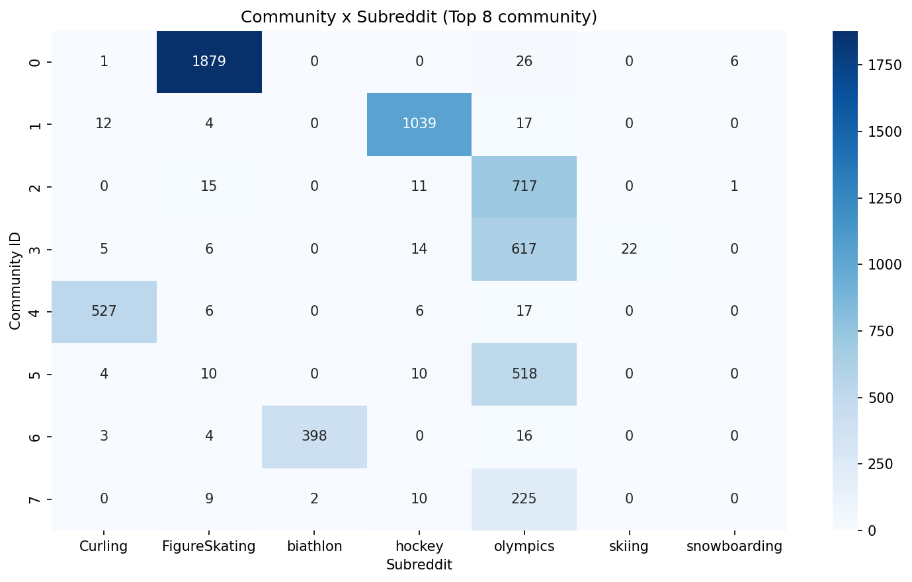
Figure 13 - Community Heatmap by Subreddit (Top 8 Communities by Size): Number of Users Per Cell.

6. CONCLUSIONS
Analysis of the Reddit conversation about Milan-Cortina 2026 has produced a complex and coherent picture. The overall sentiment is clearly positive (55%), demonstrating the enthusiasm with which the international winter sports community has welcomed the event. Biathlon and FigureSkating remain the most positive communities, while skiing displays a more critical debate.
A temporal analysis highlights a growth in sentiment in the final weeks of the analyzed period (late March 2025), consistent with the approaching Games date. The most discussed entities confirm the centrality of figure skating athletes (Alysa Liu, Kaori Sakamoto) and traditionally strong winter sports nations (Canada, USA, Norway, Germany).
At the network level, the presence of dominant hubs (Fun_With_Forks) and the strong separation of communities by subreddit suggest the existence of thematic echo chambers: users from each discipline tend to interact primarily with each other, limiting cross-pollination between different communities.
The VADER-RoBERTa comparison (57.6% agreement) suggests using the results with caution, favoring RoBERTa for ambiguous comments and VADER for a scalable analysis of the entire corpus. Future developments could include analysis during the actual Games (February-March 2026) to compare the pre-Olympic phase with the Olympic phase, and the application of topic modeling tools (LDA, BERTopic) to identify the macro-themes of the debate.
DAVIDE FABIO LORETI (865309)
CARLO PEGORARO (865329)

